**For Sale - Large Public House on a site of 0.34 Acres suitable for a variety of uses**

**Gregson Lane, Hoghton, Preston, Lancashire, PR5 0ED**

**4,647 ft² (431.71 m²)**

* Large detached building
* Suitable for a variety of uses
* 2 large car parks
* Popular location

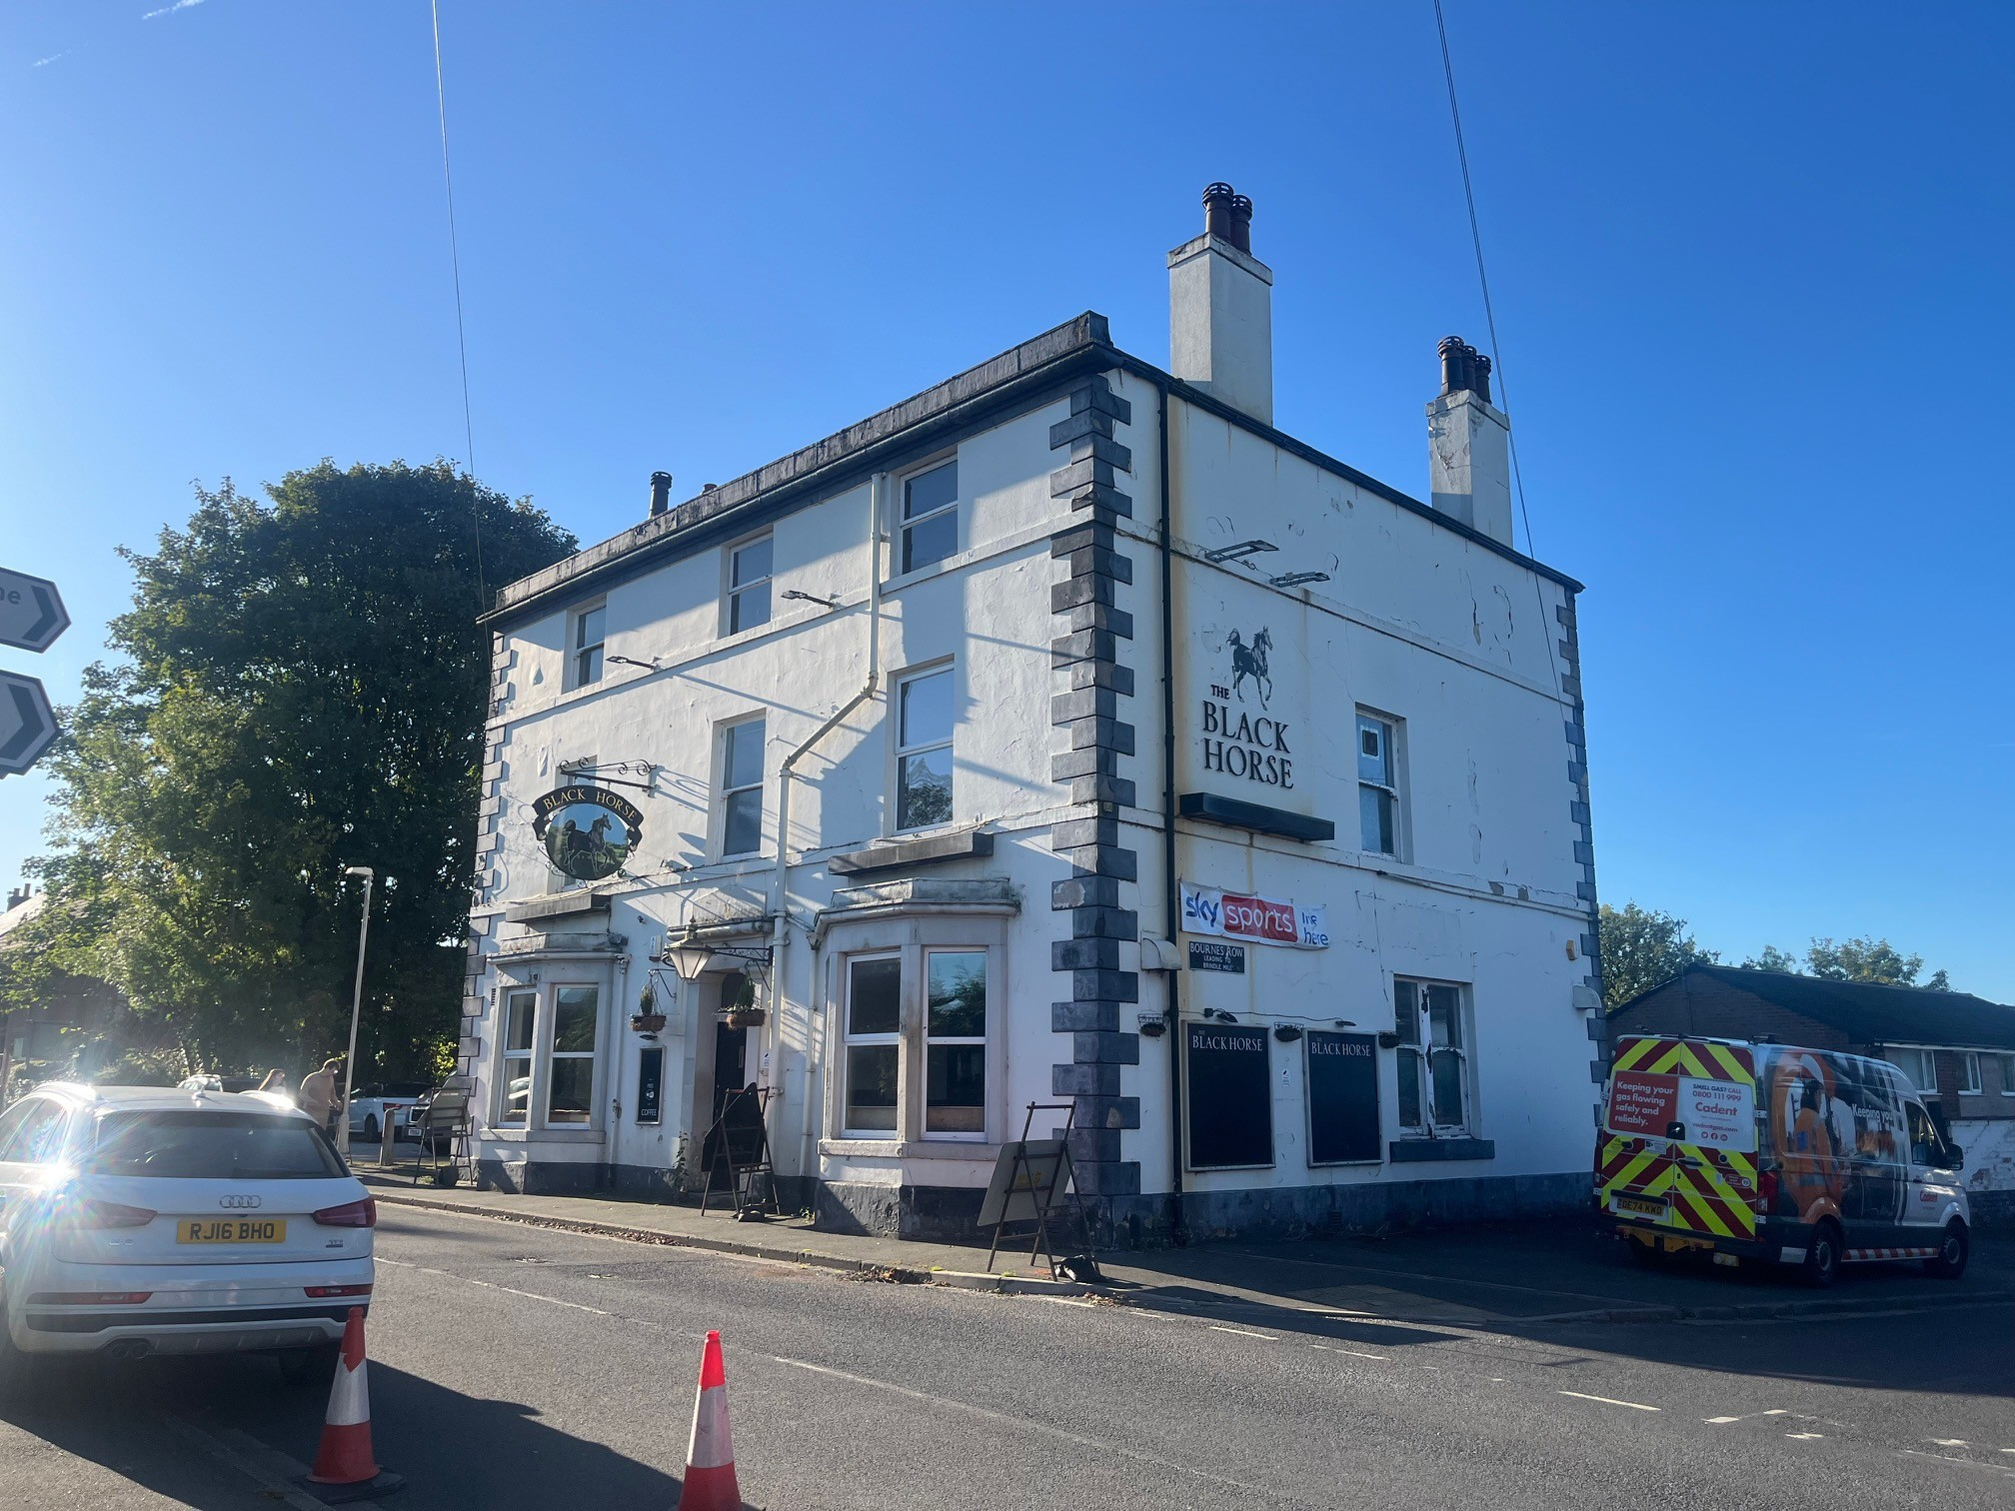

**Description**

The subject property is a detached three story public house, it has a large open plan bar area, a kitchen, male and female W.Cs and a basement for storage, along with a barrel drop.

The first floor provides living accommodation with a number of large rooms, along with a kitchen and bathroom. The 2nd floor is in need of refurbishment and provides a number of large sized rooms.

The property also has the benefit of two car parks and a small beer garden. The property is suitable for redevelopment, either conversion to residential uses or commercial use, given the size of the property and the car parking arrangements.

**Location**

The Black Horse, is located on the corner of Gregson Lane, Hoghton (near Brindle), benefits from strong road connectivity. It sits about 1.5 miles from the A675 at Riley Green, linking quickly to M65 Junction 3 for regional routes towards Preston, Blackburn and Burnley, and onward connections to the M6 and M61. Local roads provide straightforward access to Chorley and Leyland. Travel times by car are typically under 20 minutes to central Preston and Blackburn and Chorley.

**Accommodation**

The property has been measured in accordance with the latest RICS code of measuring practice on a Gross Internal Area basis (GIA) and provides the following floor areas:

Ground Floor 1,859 sq ft

1st Floor 1,388 sq ft

2nd Floor 1,399 sq ft

**Total 4,647 sq ft**

**Tenure**

We understand the property is held freehold.

**Price**

£400,000 + vat

**Planning Use**

Sui Generis - Public House

The property is suitable for a variety of uses subject to the necessary planning consents.

**EPC**

A copy of the EPC is available on request.

**VAT**

VAT is applicable at the prevailing rate

**Business Rates**

Rateable Value £10,800

**Viewing**

Viewing by way of appointment through the sole agent Fletcher CRE

01204 221 030

info@fletchercre.co.uk

Fletcher CRE for themselves and for the vendors or lessors of the property give notice that these particulars do not constitute any part of an offer or contract. Any intending purchaser or tenant must satisfy, by inspection or otherwise, as to the condition of the premises and no warranty is given by the vendor, landlord, their agents or any person in the agent's employment. Comments in this description relating the location, suitability for any purpose, aesthetic attributes, functionality or existence of services and proximity to amenities to be regarded as the agent's opinion only and not a statement of fact. Sizes quoted are approximate and given as indication only.



